

***An internship report submitted by***

**NAGEPALLI KURUBA SAI SWAROOP (Reg. No URK20CS1159)**

**NAGOTHU BALA SRIKANTH (Reg. No URK20CS1134)**

***in partial fulfillment for the award of the degree of***

**BACHELOR OF TECHNOLOGY**

***in***

**COMPUTER SCIENCE AND ENGINEERING**

***under the supervision of***

**MENTOR NAME with designation**



**DIVISION** **OF COMPUTER SCIENCE AND ENGINEERING**

**KARUNYA INSTITUTE OF TECHNOLOGY AND SCIENCES**

(Declared as Deemed to be University under Sec-3 of the UGC Act, 1956)

**Karunya Nagar, Coimbatore - 641 114. INDIA**



**DIVISION OF COMPUTER SCIENCE AND ENGINEERING**

**BONAFIDE CERTIFICATE**

This is to certify that the report entitled, Social Distancing project using Computer Vision and Deep Learning is a bonafide record of Internship work done at Intel Unnati during the academic year 2022-2023 by

NAGEPALLI KURUBA SAI SWAROOP (Reg. No:URK20CS1159)

NAGOTHU BALA SRIKANTH (Reg. No:URK20CS1134)

in partial fulfillment of the requirements for the award of the degree of Bachelor of Technology in Computer Science and Engineering of Karunya Institute of Technology and Sciences.

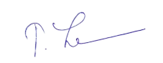

**Guide Signature**

Dr. T. Jemima Jebaseeli,

Associate professor

**ACKNOWLEDGEMENT**

First and foremost, I praise and thank ALMIGTHY GOD whose blessings have bestowed in me the will power and confidence to carry out my internship.

I am grateful to our beloved founders **Late. Dr. D.G.S. Dhinakaran, C.A.I.I.B, Ph.D** and **Dr. Paul Dhinakaran, M.B.A, Ph.D**, for their love and always remembering us in their prayers.

We entend Our tanks to **Dr. Prince Arulraj, M.E., Ph.D., Ph.D.,** our honorable vice chancellor, **Dr. E. J. James, Ph.D.,** and **Dr. Ridling Margaret Waller, Ph.D.,** our honorable Pro-Vice Chancellor(s) and **Dr. R. Elijah Blessing, Ph.D.,** our respected Registrar for giving me this opportunity to do the internship.

I would like to thank **Dr. Ciza Thomas, M.E., Ph.D.,** Dean, School of Engineering and Technology for his direction and invaluable support to complete the same.

I would like to place my heart-felt thanks and gratitude to **Dr. J. Immanuel John Raja, M.E., Ph.D.,** Head of the Division, Computer Science and Engineering for his encouragement and guidance.

I feel it a pleasure to be indebted to, Dr. T. Jemima Jebaseeli, Associate professor, Division of CSE & Mr. Mohan Nikam Intel Designation for their invaluable support, advice and encouragement.

I also thank all the staff members of the School of CST for extending their helping hands to make this in Internship a successful one.

I would also like to thank all my friends and my parents who have prayed and helped me during the Internship.

##### Title: Social Distancing Project Using Computer Vision and Deep

##### Learning

##### Team: Smooth Rock

**Date of submission:** 15/07/2023

The project was carried out by the following team members:

1) Nagepalli Kuruba Sai Swaroop([nagepallikuruba@karunya.edu.in](mailto:nagepallikuruba@karunya.edu.in) )

2) Nagothu Bala Srikanth([nagothubala@karunya.edu.in](mailto:nagothubala@karunya.edu.in) )

We would like to express our gratitude to our mentors for providing guiding and support the internship:

1) Dr. T. Jemima Jebaseeli(Academic mentor) - [jemima_jeba@karunya.edu](mailto:jemima_jeba@karunya.edu)

2) Mr. Mohan Nikam(Industry mentor)- [mohannikam@theprograms.in](mailto:mohannikam@theprograms.in)

**CONTENTS**

**Page no.**

**1. Abstract 1**

**2. Introduction 2**

**3. Motivation behind the problem 2**

**4. Prior Work 3**

**5. Our Approach 3**

**5.1 Model Configuration and Training 3**

**5.2 Deployment with OpenVINO 3**

**5.3 Social Distancing Monitoring System 4**

**6. Conclusion 4**

**7. Results 5**

**8. References 6**

1. **Abstract:**

Ensuring compliance with social distancing guidelines has become paramount in curbing the transmission of infectious diseases. As the world continues to grapple with the COVID-19 pandemic, innovative solutions are being sought to monitor and enforce social distancing protocols effectively. In this technical report, we present a cutting-edge solution that combines computer vision techniques, deep learning, and edge computing to tackle this challenge.

Our proposed system leverages the YOLOv8 object detection model and the Open VINO toolkit, enabling real-time monitoring and analysis of individual’s spatial proximity. By using computer vision algorithms, our system can detect and track individuals with high accuracy. It analyses their movements and calculates the distance between them to identify potential social distancing violations.

To accelerate inference on edge devices and optimize the performance of the YOLOv8 model, we integrate the Open VINO toolkit. This ensures fast and efficient processing of the captured video streams, making our system capable of real-time detection and tracking in various environments. By utilizing edge computing, we minimize the dependency on cloud infrastructure and enable deployment in remote or resource-constrained areas.

Experimental evaluations demonstrate the effectiveness of our system in detecting and flagging social distancing violations. The combination of YOLOv8 and Open VINO achieves a remarkable level of accuracy, which makes it a valuable tool for public health authorities, organizations, and businesses. By identifying areas where social distancing is not being properly followed, appropriate measures can be taken to minimize the spread of infectious diseases and protect public health.

1. **Introduction**

The pandemic has highlighted the critical importance of implementing and adhering to social distancing measures in order to curb the transmission of infectious diseases. However, effectively monitoring and enforcing compliance with these guidelines in public spaces present numerous challenges. In response, we propose a novel solution that harnesses the power of advanced technology. By leveraging the YOLOv8 object detection model and the Open VINO toolkit, we aim to develop a sophisticated system capable of real-time monitoring and enforcement of social distancing measures. This innovative approach will enable authorities to proactively identify instances of inadequate distancing and promptly take the necessary measures to address them. By combining the versatility of the YOLOv8 model with the efficiency of the Open VINO toolkit, we can ensure that this solution is not only accurate but also capable of handling the demanding real-time monitoring requirements of crowded areas. With the implementation of this system, we can enhance public safety and contribute to the overall wellbeing of communities by providing a reliable and effective tool for monitoring and enforcing social distancing measures.

1. **Motivation behind the problem**

A social distancing project is motivated by the urgent need to protect public health and halt the rapid transmission of contagious diseases. By implementing and enforcing social distancing measures, the project aims to contain and mitigate the spread of infectious illnesses, such as COVID-19. The primary goal is to minimize close contact and maintain physical distance between individuals, which has been proven effective in slowing down the transmission rate. This, in turn, helps prevent overwhelming healthcare systems and reduces the burden on medical resources. By flattening the curve of infections, the project seeks to protect the well-being of individuals, particularly vulnerable populations, such as the elderly and those with underlying health conditions. Additionally, social distancing measures contribute to economic recovery by minimizing the need for prolonged lockdowns or restrictions. The project serves to raise public awareness and educate communities about the significance of social distancing, fostering a collective responsibility to adhere to guidelines and ensure the health and safety of all.

1. **Prior Work**

Several studies and projects have focused on utilizing deep learning techniques for social distancing applications. These works have demonstrated the potential of deep learning in effectively monitoring, enforcing, and promoting social distancing guidelines. Project focused on crowd density estimation using deep learning. By analysing video footage, the deep learning models could accurately count the number of people in a specific area. This information was then used to estimate crowd density levels and identify potential overcrowding situations where social distancing might be compromised. The project aimed to assist organizations in managing crowd density effectively and enforcing social distancing measures in public spaces.

These prior works highlight the versatility and effectiveness of deep learning in various aspects of social distancing. The use of deep learning models enables real-time monitoring, accurate crowd density estimation, contact tracing, automated public health monitoring, and occupancy management. Continued research and development in this field hold promise for further advancements in social distancing applications using deep learning techniques.

1. **Our Approach**

**5.1 Model Configuration and Training**

The YOLOv8 object detection model is widely recognized for its accuracy and efficiency in detecting objects. This state-of-the-art architecture is designed to provide reliable performance in real-world settings. To ensure its robustness, the model is trained on a comprehensive dataset that encompasses various environments and scenarios. This extensive training allows the YOLOv8 model to accurately identify objects in different contexts, ranging from crowded city scenes to natural landscapes. With its ability to detect objects in real-time, this model has valuable applications in various fields, including autonomous driving, surveillance systems, and augmented reality. Its superior performance and versatility make YOLOv8 a go-to choice for object detection tasks that require both precision and speed.

**5.2 Deployment with OpenVINO**

To optimize the YOLOv8 model for efficient inference on edge devices, we leverage the OpenVINO toolkit. OpenVINO provides a comprehensive set of model optimization techniques that greatly enhance the performance and resource efficiency of the YOLOv8 model. One such technique is model quantization, which allows for the reduction of model precision without significant loss in accuracy. By quantizing the model, we can represent the weights and activations using fewer bits, resulting in a smaller model size and faster processing. Additionally, Open VINO offers hardware acceleration capabilities, taking advantage of the unique capabilities of edge devices' hardware to further optimize the YOLOv8 model's inference speed and resource requirements. Through Open VINO, we are able to leverage the power of edge devices to deploy YOLOv8 models efficiently, enabling real-time object detection and recognition in resource-constrained environments. With faster inference and reduced resource requirements, the YOLOv8 model becomes an ideal solution for various edge computing applications, such as surveillance systems, smart cameras, and autonomous vehicles, ensuring accurate and efficient real-time detection and analysis of objects of interest.

**5.3 Social Distancing Monitoring System**

Our system is designed to ensure the safety of individuals by following a comprehensive three-step process: person detection, tracking, and social distance analysis. To detect and localize individuals in each video frame, we make use of the YOLOv8 model, which has proven to be highly effective. This allows us to accurately identify the presence of people in any given frame, providing a solid foundation for the subsequent steps. Once these individuals are detected, we employ advanced algorithms such as Kalman filtering or the Hungarian algorithm to track their movements over time. These algorithms are robust and reliable in maintaining a consistent tracking of individuals, even in complex or crowded scenarios. Finally, we analyze the social distance between tracked individuals using the Euclidean distance metric. By calculating the spatial proximity between individuals, we can pinpoint any violations of predefined distance thresholds. This comprehensive approach ensures that our system can effectively identify and address any instances where individuals fail to maintain a safe distance from one another.

1. **Conclusion:**

In conclusion, The integration of the OpenVINO toolkit with deep learning model further enhanced the efficiency and performance of social distancing systems. OpenVINO enables optimized inference and deployment of deep learning models on a wide range of hardware, ensuring fast and efficient processing of data. This empowers social distancing projects to handle large-scale scenarios and real-time monitoring with improved accuracy and reduced computational overhead

1. **Results:**

The project Social Distancing Project Using Computer Vision and Deep Learning is successful using Yolov8 and the model is optimized with the openVINO toolkit for better efficiency and performance

Without OpenVINO:

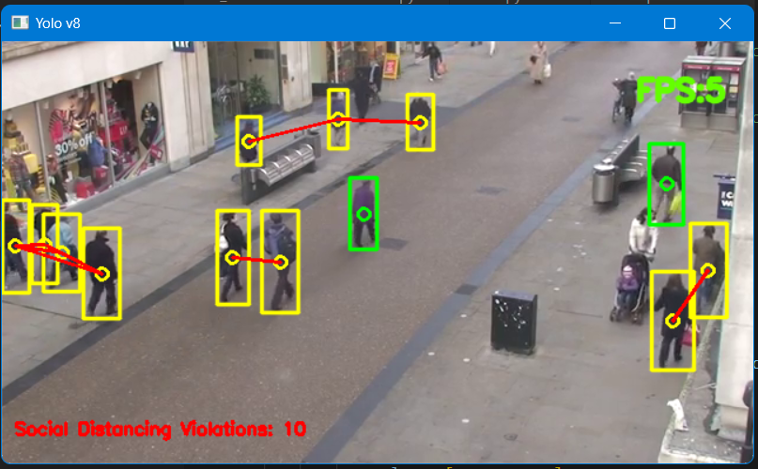

With OpenVINO:

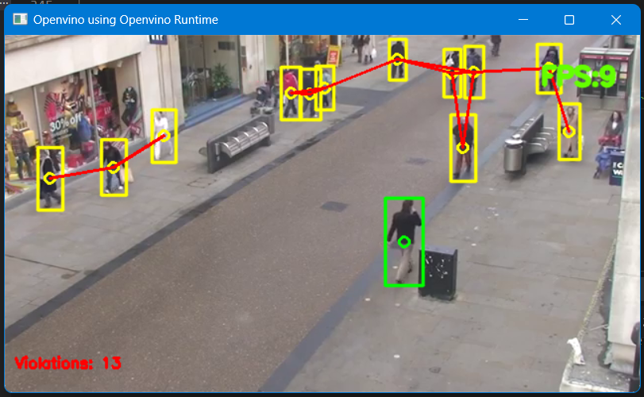

**Github link:** https://github.com/swaroopNKS/intelunnati_Smooth_Rock

1. **References:**
2. <https://docs.ultralytics.com/hub/>
3. <https://www.intel.com/content/www/us/en/developer/tools/openvino-toolkit/download.html?ENVIRONMENT=DEV_TOOLS&OP_SYSTEM=WINDOWS&VERSION=v_2023_0_1&DISTRIBUTION=PIP>
4. <https://docs.openvino.ai/2023.0/notebooks/230-yolov8-optimization-with-output.html>
5. <https://github.com/openvinotoolkit/openvino_notebooks/blob/main/notebooks/230-yolov8-optimization/230-yolov8-optimization.ipynb>
6. <https://github.com/ibaiGorordo/ONNX-YOLOv8-Object-Detection>

**Top of Form**

**Bottom of Form**